Hello fellow Norman Parkie,

Over the next 2 weeks we will be conducting an initiative called, ‘What’s the new value of your home’. We appraise homes in every street of Norman Park and provide a full report on current prices in the area and the change in demographics and trends.

The market finished strong in December 2016 and continues to stay strong in January and February. Recent sales in Norman Park:

- 10 Dickens street $1,040,000 30 Overed Street $899,000
- 59 Moreton street $920,000 83 Power street $1,300,000
- 4 Frank Street $880,000 31 Waldo St $1,820,000

For the year of 2016 x 116 houses in Norman Park were sold, with an average price of $987,802
*Data supplied by Corelogic.

We will be offering our expert opinion on prices of every home in the Norman Park area and the appraisal will only take about 10 – 15 minutes of your time.

What will you receive?
- What’s your Home’s New Value?
- How do you go about selling or buying a home?
- Report on every recorded sale in Norman Park over the last 6 months

How do you participate?
Contact me directly on 0408 117 299 or a Alternatively you can e-mail me at rachelfechner@mcgrath.com.au. We will then schedule your home to be appraised.

Confidentiality will be adhered to for each property we appraise.
Whether you want to sell or stay..
I would love to meet you.

Kind Regards,
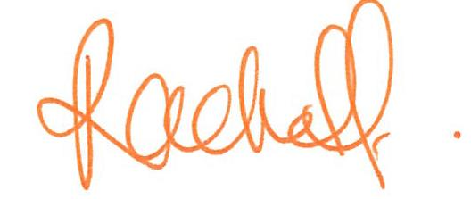
Rachel Fechner
M 0408 117 299
E rachelfechner@mcgrath.com.au “Norman Park is not just my area…It’s my home”
W mcgrath.com.au

