13th March 2017

Hello fellow Norman Parkies,

From time to time, all of us are going to need or want professional and reliable real estate advice.

So instead of you receiving the usual noise from Agents, I’d like to change it up.… and be an agent that provides you ‘Service’… Yes.. that’s right, you haven’t misread it!

This week I thought I would start with the first of 7 simple steps to consider when selling your home. Over the coming weeks, I will share a step each week.

Step #1
Be clear on your motivation
- Downsizing/upsizing
- Purchased another property
- Financial pressure
- Relocation
- Other

If you simply can’t wait for the remaining simple steps, give me a shout and I would be more than happy to have a chat and share…

Whether you’re looking to sell or stay, I would love to meet you!

Kind Regards,
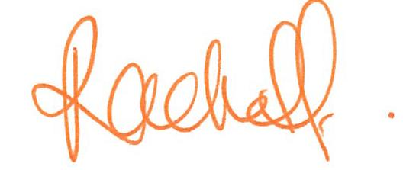
Rachel Fechner
M 0408 117 299
E rachelfechner@mcgrath.com.au ‘Not only is Norman Park my area....it’s my home’
W mcgrath.com.au

