20th March 2017

Hello fellow Norman Parkies,

Last week I provided you with step #1 when considering selling your home.

This week I’m giving you step #2 to take into consideration and if you missed last week, no dramas, just send me an email and I will send through step #1.

Oh and last week there were 4 more sales in Norman Park;
- 54 Overend Street Norman park SOLD $745,000
- 1/70 Overend Street Norman Park SOLD $600,000
- 69 Thackeray Street Norman Park SOLD $1,375,000
- 20 Overend Street Norman Park SOLD $850,000

Over the coming weeks, I will share a step each week.

Step #2 Location
It’s important to take the following into consideration

- Where is your property priced in relation to other properties in your location (always allow for the uniqueness of each property)?
- What type of neighbourhood is your property located in – well established, up and coming, transitional?
- Things to promote:
  - Public transport | Main Roads | Shopping Centres | Schools & Other educational centres | Medical centres or Hospitals | Outdoor parks, public pools, playgrounds | Entertainment venues

If you simply can’t wait for the remaining simple steps, give me a shout and I would be more than happy to have a chat and share…

Whether you’re looking to sell or stay, I would love to meet you!
Kind Regards,
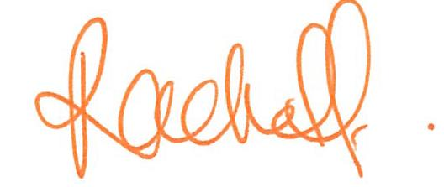
Rachel Fechner
M 0408 117 299
E rachelfechner@mcgrath.com.au ‘Not only is Norman Park my area....it’s my home’
W mcgrath.com.au

