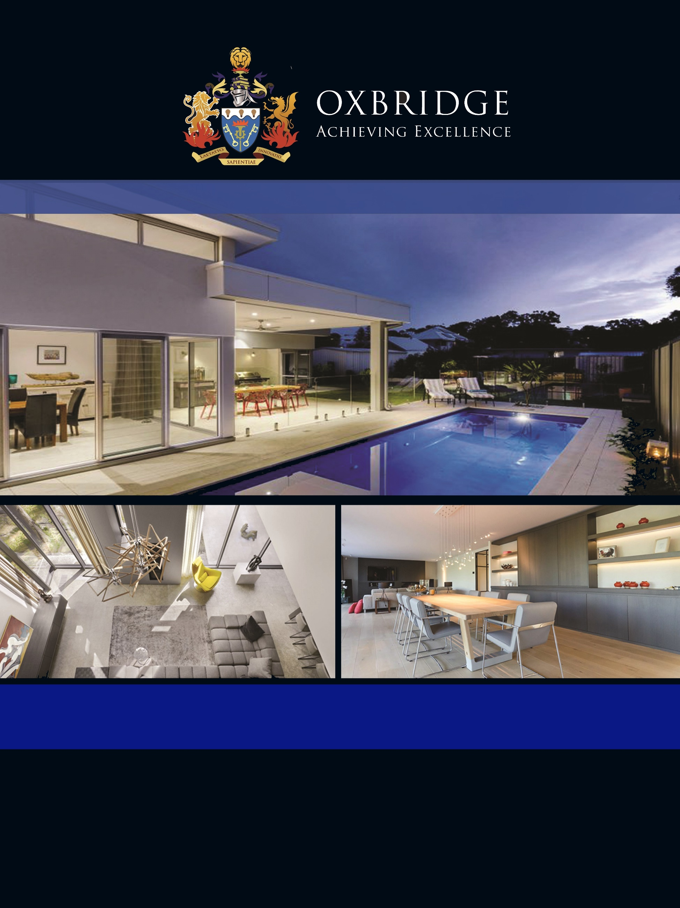

JOHN SMITH

MARKETING BROCHURE





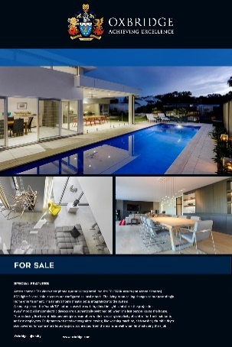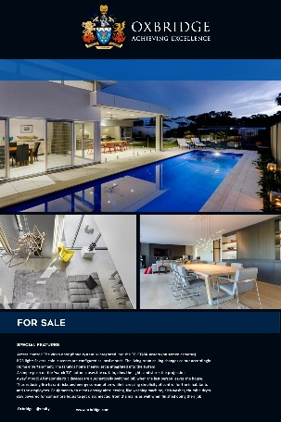

|  |  |  |  |  |  |  |
| --- | --- | --- | --- | --- | --- | --- |
| **TEXT SIGN**  **(900 x 1200mm)** | **6X4 PHOTO SIGN**  **(1800 x 1200mm)** | | **8X6 PHOTO SIGN**  **(2400 x 1800mm)** | | **8X10 PHOTO SIGN**  **(2400 x 3000mm)** | |
| **SIGNS** | | **PHOTOS** | | **FLOORPLAN** | |
| 4x3 (900x1200mm) TEXT ONLY SIGN **$66**  6x4 (1800X1200mm) TEXT ONLY SIGN **$99**  6x4 (1800X1200mm) PHOTO SIGN  **$170**  8x6 (2400X1800mm) PHOTO SIGN  **$340**  8x10 (2400X3000mm) PHOTO SIGN **$695**  **FLAT PACK SIGNS: (RURAL PROPERTIES)**  4x3 (900x1200mm) TEXT ONLY SIGN | **$180.20**  6x4 (1800X1200mm) PHOTO SIGN **$285.20** | | 10 X STANDARD DAYTIME PHOTOS  **$99.20**  15 X STANDARD DAYTIME PHOTOS  **$124.20**  5 X PREMIUM DAYTIME PHOTOS  **$119.21**  10 X PREMIUM DAYTIME PHOTOS  **$159.20**  15 X PREMIUM TWILIGHT PHOTOS  **$254.20**  DRONE PHOTOGRAPHY  **$410** | | SINGLE LEVEL FLOOR PLAN 2D B/W  **$79.20**  DOUBLE LEVEL FLOOR PLAN 2D B/W  **$129.20**  FLOOR PLAN 2D COLOUR  **additional $20.00**  FLOOR PLAN 3D COLOUR  **additional $60.00** | |
|  | |  | |  | |
|  | |  | |  | |
|  | |  | |  | |
|  | |  | |  | |
|  | |  | |  | |
|  | |  | |  | |







|  |  |  |  |  |  |  |
| --- | --- | --- | --- | --- | --- | --- |
| **TEXT SIGN**  **(900 x 1200mm)** | **6X4 PHOTO SIGN**  **(1800 x 1200mm)** | | **8X6 PHOTO SIGN**  **(2400 x 1800mm)** | | **8X10 PHOTO SIGN**  **(2400 x 3000mm)** | |
| **BROCHURE PACKS** | | **TEXT SIGN PACKAGES** | | **PHOTO SIGN PACKAGES** | |
| 50 x A4 BROCHURES +  200 x A6 BROCHURES **$55**  50 x A4 BROCHURES +  100 x DL BROCHURES  **$55**  100 x A4 BROCHURES  **$55**  400 x A6 BROCHURES  **$55**  200 x DL BROCHURES  **$55**  50 x 4PG SQUARE BOOK +  100 x DL BROCHURES **$191** | | **SIGN PACK 1**  TEXT SIGN + 50 X A4 +  200 X A6 OR 100 X DL BROCHURES  **$121**  **SIGN PACK 2**  TEXT SIGN + 50 X A4 +  200 X A6 OR 100 X DL BROCHURES +  10 X DAYTIME PHOTOGRAPHY  **$220.20**  **SIGN PACK 3**  TEXT SIGN + 50 X A4 + 200 X A6 OR 100 X DL BROCHURES +  10 X DAYTIME PHOTOGRAPHY + BLACK & WHITE FLOOR PLAN  **$320.20** | | **SIGN PACK 1**  PHOTO SIGN 50 X A4 +  200 X A6 OR 100 X DL BROCHURES  **$240**    **SIGN PACK 2**  PHOTO SIGN + 50 X A4 +  200 X A6 OR 100 X DL BROCHURES +  10 X DAYTIME PHOTOGRAPHY  **$303.40**    **SIGN PACK 3**  PHOTO SIGN + 50 X A4 + 200 X A6 OR 100 X DL BROCHURES +  10 X DAYTIME PHOTOGRAPHY + BLACK & WHITE FLOOR PLAN  **$430** | |
|  | |  | |  | |
|  | |  | |  | |
|  | |  | |  | |
|  | |  | |  | |
|  | |  | |  | |
|  | |  | |  | |



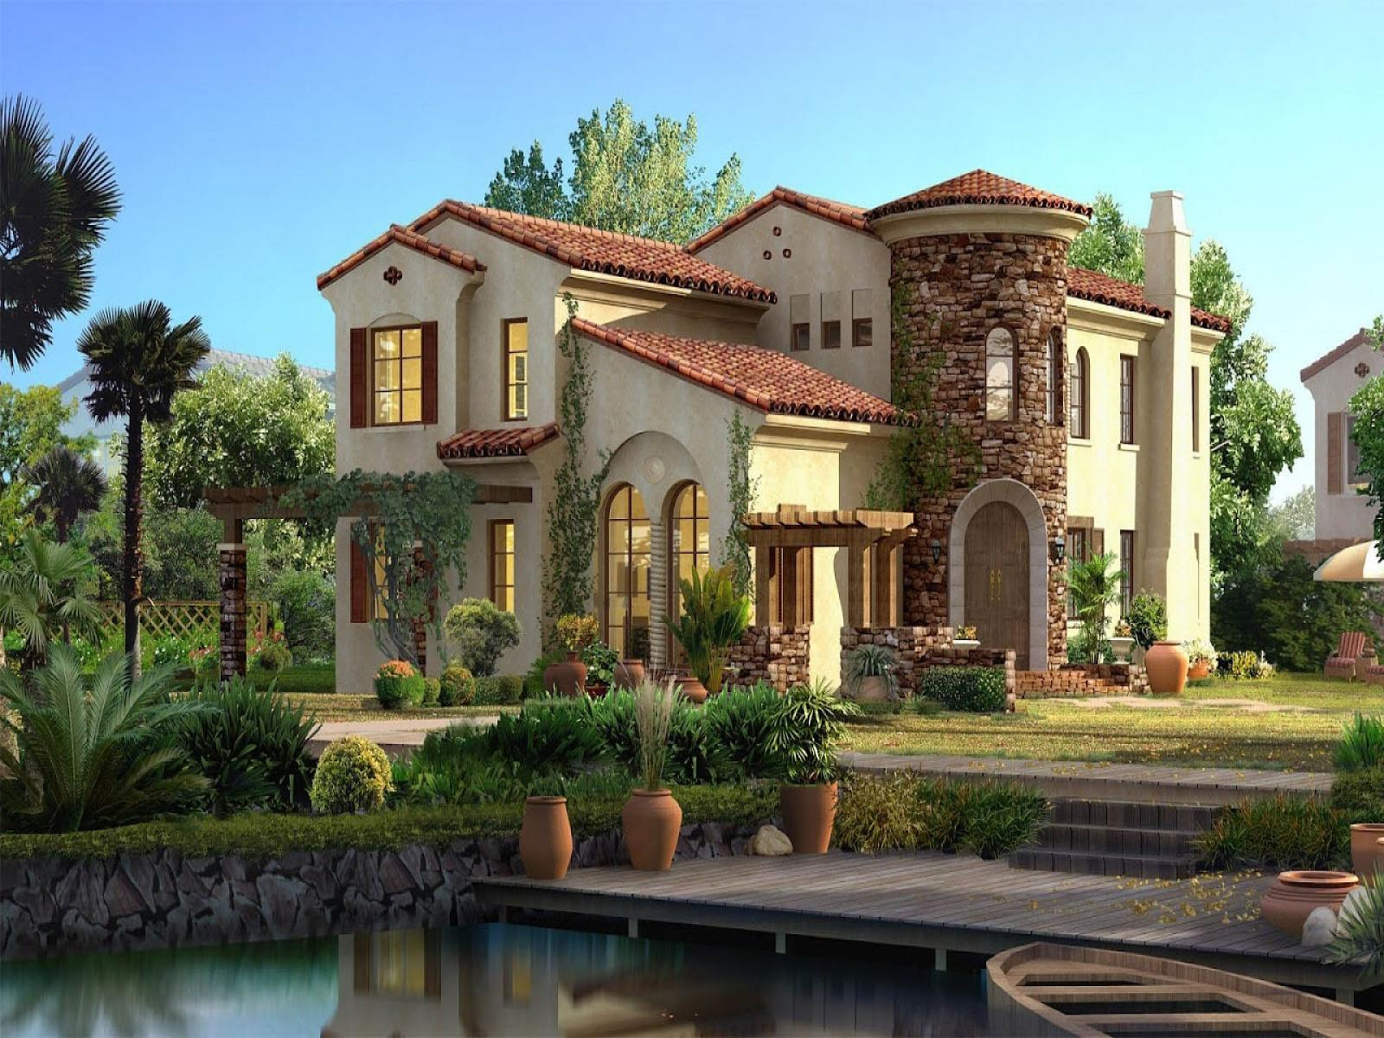

|  |  |  |  |  |
| --- | --- | --- | --- | --- |
| **FREE STANDARD ONLINE ADVERTISING ON THESE WEBSITES**   |  |  | | --- | --- | | * **FREE DOMAIN.COM.AU LISTING** * **FREE HOMESALES.COM.AU LISTING** * **FREE ONTHEHOUSE.COM.AU LISTING** * **FREE REALESTATEVIEW.COM.AU LISTING** * **FREE OXBRIDGE.COM.AU LISTING** * **FREE SQUIIZ.COM.AU LISTING** * **FREE HOMELY.COM.AU LISTING** * **FREE SOHO APP** * **FREE RENET** * **FREE FACEBOOK LISTING** * **FREE TWITTER LISTING** * **FREE INSTAGRAM LISTING** | * **FREE ALLHOMES.COM.AU** * **FREE EAC (REAL ESTATE WORLD)** * **FREE HOME HOUND** * **FREE LOCAL HOMES** * **FREE MEHOUSE** * **FREE LUXURYLIST.COM.AU** * **FREE RENT.COM.AU** * **FREE RENTBUY** * **FREE RENTFIND** * **FREE THE HOMEPAGE** * **FREE TRADING POST** * **FREE IVISUAL** * **REALESTATE.COM.AU | $100 PER LISTING** | | | |
|  |  |  |
|  |  |  |
|  |  |  |
|  |  |  |
|  |  |  |
|  |  |  |



|  |  |  |  |  |
| --- | --- | --- | --- | --- |
| **TOTAL AMOUNT:**  **PAYMENT INFORMATION**   |  |  | | --- | --- | | **CREDIT/DEBIT CARD:**  VISA MASTER CARD AMEX  (1.75%) (1.75%) (3.1%)  NAME:_________________________________ NUMBER: ______________________________  EXPIRY:___/_______ CVV ______  SIGNATURE: ____________________________ | **DIRECT TRANSFER:**  OXBRIDGE TRUST ACCOUNT:  BSB: 084-034  Account:88-905-3501  INTEREST FREE INSTALMENT PAYMENT AVAILABLE WITH **AFTERPAY AND EZIDEBIT**  PAYMENT ONLINE AT **WWW.OXBRIDGEMARKETING.COM.AU** | | | |
|  |  |  |
|  |  |  |
|  |  |  |
|  |  |  |
|  |  |  |
|  |  |  |