Date;

Hello fellow Norman Parkies,

When you decide to sell your home, there are several decisions you’ll need to make and many things to be done. Selling your home can often be a stressful and complicated process, however I would like to uncomplicate it and make it less stressful.
Take a deep breath! There is plenty of help available which has been tried and tested that you can use to boost your chances of success.

Step #3 Maximising Street Appeal
Some inexpensive ways to maximise your home’s street appeal;
- For that lick of paint, go for neutral tones and the most popular choice of paint to ensure the widest appeal
- Note that no DIY work is better than bad quality DIY work
- Landscaping, this is what people see first! If it’s neat and tidy, then the assumption will be the inside will be well maintenance
- Remember that from the moment your property is on the market, people will be driving by and assessing the property, the house needs to look great from the outside as we want them to come in, not keep driving pass
- Get rid of dead trees, branches, weed and any vines that are invasive as well as keep garden equipment out of sight, children toys
- Any unused outdoor furniture or mixed matched or broken, get rid of it!
- Wash dirt, mould and grime off outside walls, roof, garage doors, faded walkways and driveways. The good old pressure washer is the best and can be hired if you don’t have one.
- Essential is decluttering each room in your home, not only making your home look clean and tidy, it also makes the rooms appear bigger.

If you simply can’t wait for the remaining simple steps, give me a shout and I would be more than happy to have a chat and share.

Whether you’re looking to sell or stay, I would love to meet you!
Kind Regards,
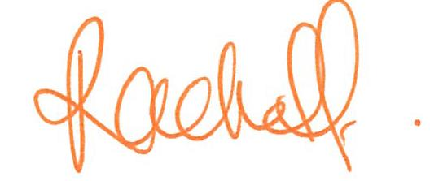
Rachel Fechner
M 0408 117 299
E rachelfechner@mcgrath.com.au ‘Not only is Norman Park my area....it’s my home’
W mcgrath.com.au

