10th April March 2017

Hello fellow Norman Parkies,

Having great information about selling you home is about, searching the internet, read your local newspapers, speak to people who have bought and sold in your area lately and to Me your local agent. One of the services that I can provide you with is, monthly or quarterly reports of recent sales and how sales are stacking up in our area.
Step #5 Choosing the right agent
You need to be confident that your agent will secure the best possible price for your home and isn’t just in it for a cheap, quick sale!

- Be up to speed with what’s selling in your area – your local Agent – I can assist you with this.

- Get out there and act like a buyer and visit properties for sale in your area to get a sense of your property’s value.

- Make a short list potential agents in your area by talking to friends.

- Visit Agents openings to see how they conduct themselves and what follow up there is?

- Interview with less two to three agents.

- Ask a lot of questions, do they have a good understanding of the area and market conditions.

- Look at the individual not necessary at their Brand.

- Ensure you feel comfortable with an agent and that there’s a good rapport. Selling you greatest asset successfully will require a partnership between the two of you and you need to feel you can work together as a team.

- Commission fees – this is always a great source of pain for Sellers.
It’s simple you pay for what you get. If an agent drops their commission too quickly if there not good at negotiating well at the start how are they going to negotiated with potential buyers?.

If you simply can’t wait for the remaining simple steps, give me a shout and I would be more than happy to have a chat and share.

Whether you’re looking to sell or stay, I would love to meet you!
Kind Regards,

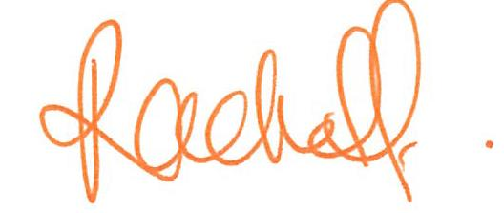
Rachel Fechner
M 0408 117 299
E rachelfechner@mcgrath.com.au ‘Not only is Norman Park my area....it’s my home’

