24th April March 2017

Hello fellow Norman Parkies,

Yep, this is the one that you are going to love! The cost of selling your home. Some of you have probably sold and brought and have some understanding, but for those of you that haven’t here we go.

Step #7 Cost of Selling
There are several costs associated with selling your home, we’ve touch on it in Step #5 Commission to the agent, then other costs include, advertising/marketing, investment taxes, photography, valuation and building, and pest.

- The Agent will discuss with you all costs, you need to make sure that you completely understand what is been presented to you. If in doubt, ask the question.

- Depending upon your home and the marketing involved to cast the net wide this can be anywhere from $1000 up to $30,000. The biggest cost of advertising is print adverting. You can pick yourself up off the floor NOW. You would be surprised to hear that paper advertising is growing at a rapid rate in Brisbane and I have no doubt that you seen in Saturday Courier Mail real estate lift out – it is very impressive. There is a strategy around this and happy to discuss further.

- A good agent can add 10% onto the sale price of your home, a good agent will be clear on the fees involved. A good agent will help you with access to tradesman etc if required as they often know quality trades at competitive prices amongst other things. A good agent is proactive, not reactive and will work with you right up until settlement and beyond.

“Price is what you pay, Value is what you get” – Warren Buffet

If you simply can’t wait for the remaining simple steps, give me a shout and I would be more than happy to have a chat and share.

Whether you’re looking to sell or stay, I would love to meet you!
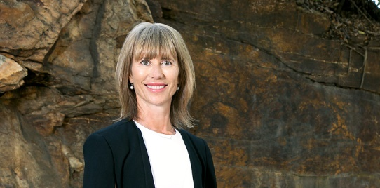
Kind Regards,

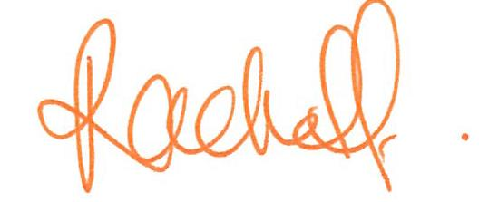
Rachel Fechner
M 0408 117 299
E rachelfechner@mcgrath.com.au ‘Not only is Norman Park my area....it’s my home’

