1st May 2017

Hello fellow Norman Parkies,

Well, this is the last one in steps! You know how I said that step #7 you would love, ok I lied! Step #8 is about pricing and this is one is very important!
Why is price important you ask because the way your home is marketed can make or break the deal;
Step #8 Pricing

As an agent, developer and homeowner myself we seek advice from professionals, agents and depending upon the information provided and advice given it can either please you or upset you.
We all believe our homes are the best in the street and that the highest price will be paid. We also know that our buyers are very savvy now, they research & research and where the value sits. So marketing your home is about strategy, been realistic, motivated to sell.

- Over-pricing of your home may result in:
  - A smaller buyers pool, no buyers, or the wrong demographic
  - A prolonged stay on the market that will result in lower offers being submitted
- Under-pricing of the home may result in;
  - You losing money on your investment or biggest asset.

If you come to the point where you are ready to sell and want to know more about the different strategies that have been tried and tested, give me a call.

If for any reason, you have missed a step or would like to have an informative discussion, please feel free to give me a call.

Whether you’re looking to sell or stay, I would love to meet you!

Kind Regards,

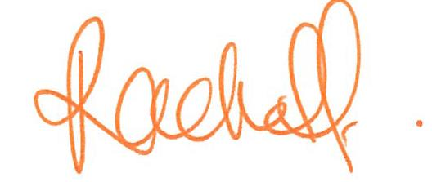
Rachel Fechner
M 0408 117 299
E rachelfechner@mcgrath.com.au ‘Not only is Norman Park my area....it’s my home’

