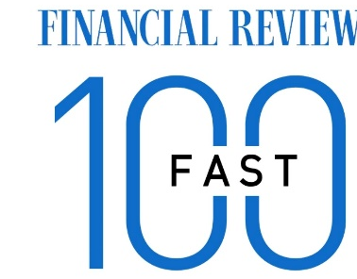
Dear Sir/Madam,
Our names are XXXX. We are your local real estate professionals with a large team of sales people and property managers. We operate our company under the Oxbridge brand. Oxbridge is now one of the fastest growing agencies in Australia and New Zealand with over 1,200+ agents. Please find enclosed a brief introduction to ourselves and to our company.
We recently sold a number of properties in your suburb, some of which in record time at record prices. We are experiencing strong demand from buyers to purchase and to rent in your suburb.
If you are thinking of selling, or renting or want a complimentary valuation or market update, please do not hesitate to contact us. WE DO NOT CHARGE UPFRONT MARKETING FEES WHEN YOU SELL OR RENT YOUR HOME. We also offer a competitive rate for rental management (4%-7%) and we are one of the few agencies that can manage properties on a room by room (rooming) and short-term (hotel management) basis to increase your rental yield. Some of our properties are achieving over 10% gross return. You will ALWAYS receive professional, prompt and courteous service.
We thank you so very much for your consideration,
Yours faithfully,

Dr Paul Howe
ABOUT DR PAUL HOWE & TEAM
Oxbridge is a modern real estate agency and development company that currently connects the largest network of sales and property management affiliates across Australia. Every agent is able to connect with each other and access a large, ever growing network of buyers to provide maximum exposure to our client's properties. Oxbridge operates as one large office, providing exceptional buying power with suppliers, so clients can be sure they are receiving great value at all times. We offer the best personal service of a traditional real estate practice, fused with fully interactive digital technology and a modern approach so that we can best give our clients exceptional service.
<Agent Profile>
Dr Paul Howe
Paul graduated with First Class Honours from Sydney University and subsequently was selected as a Commonwealth Trust scholar to Oxford University (receiving a Masters in Finance), followed by a PhD at Cambridge University in Quantitative Finance. He has lived and worked as an investment advisor in the USA, UK, China, Hong Kong and Australia, and was Vice President of one of the largest funds in the world.

