QR code and Link for joining the Melb Property Expo team (for existing Oxbridge member agents who is going to the Melb Property Expo)

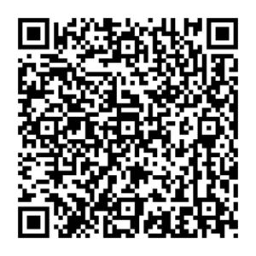

https://service.arcnet.com.au/arc-qr-web/?agencyid=296085870&departmentid=1534038542

