QR codes to be displayed for sharing project info to potential buyers

- Natura-Coomera
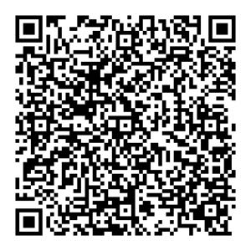

- Imperial Square (regal residences) Southport
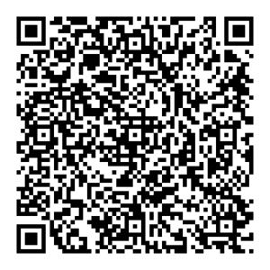

3. STH BNK BY BEULAH in Melbourne.
